Git - Tracked and Untracked Files

Git Clean

🔹 What is Git Clean?
# Source: AI Source: Provided by: [Data Path: Persons Table -> ID Column: 1, Name_En Column: Motasem Essam] -> From: [ChatGPT] on [2/19/2026]
git clean is a Git command used to remove untracked files and directories from your working directory (workspace).
Think of it as a “cleanup tool” for files that Git is not tracking.

🔹 What It Does
# Source: AI Source: Provided by: [Data Path: Persons Table -> ID Column: 1, Name_En Column: Motasem Essam] -> From: [ChatGPT] on [2/19/2026]
- Preview what will be deleted:
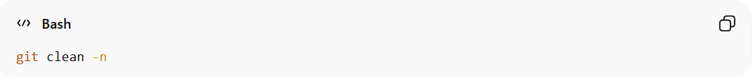
git clean -n
- Lists untracked files and directories that would be removed.
- Safe way to check before deleting.

- Remove untracked files:
git clean -f
- Deletes all untracked files (files never staged or committed).

- Remove untracked directories as well:
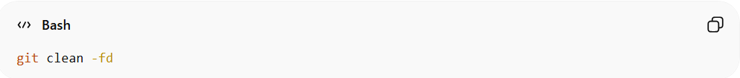
git clean -fd
- -f → force deletion
- -d → include directories

- Interactive mode:
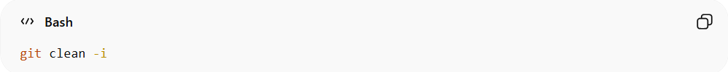
git clean -i
- Lets you choose which files or directories to delete.

🔹 Where It Fits in Git Workflow
# Source: AI Source: Provided by: [Data Path: Persons Table -> ID Column: 1, Name_En Column: Motasem Essam] -> From: [ChatGPT] on [2/19/2026]
Git Workflow:
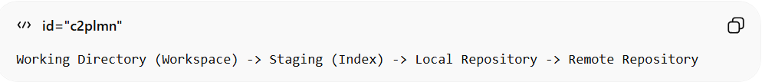
Working Directory (Workspace) -> Staging (Index) -> Local Repository -> Remote Repository
- git clean operates only on the Working Directory (Workspace).
- Deletes files that are not tracked in Staging or Local Repository.
- Does not affect commits.

🔹 Key Notes
# Source: AI Source: Provided by: [Data Path: Persons Table -> ID Column: 1, Name_En Column: Motasem Essam] -> From: [ChatGPT] on [2/19/2026]
- Only removes untracked files and directories.
- Cannot restore files after deletion unless you have a backup.
- Use git clean -n first to preview.

Example

Preview what will be deleted

1️⃣ Create a new test project
# Source: ScreenShots Source: Provided by: [Persons Table -> ID Column: 1, Name_En Column: Motasem Essam] -> Tool: [Lightshot Program] -> From [Operating System: Windows] on [2/19/2026]
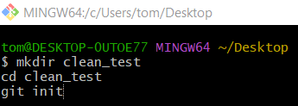
mkdir clean_test
cd clean_test
git init
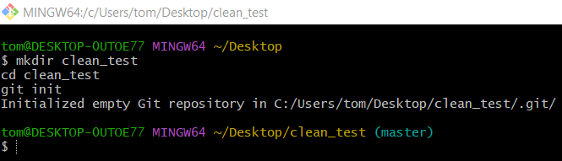

2️⃣ Create a tracked file
# Source: ScreenShots Source: Provided by: [Persons Table -> ID Column: 1, Name_En Column: Motasem Essam] -> Tool: [Lightshot Program] -> From [Operating System: Windows] on [2/19/2026]
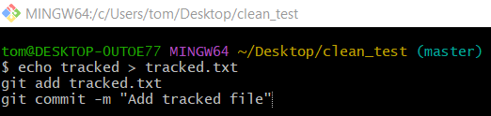
echo tracked > tracked.txt
git add tracked.txt
git commit -m "Add tracked file"
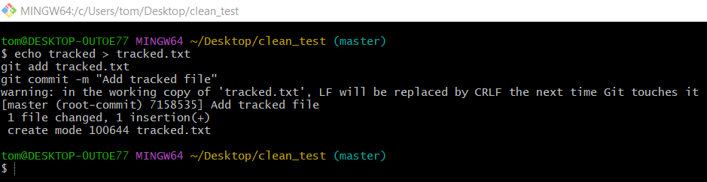

3️⃣ Create untracked files and folders
# Source: ScreenShots Source: Provided by: [Persons Table -> ID Column: 1, Name_En Column: Motasem Essam] -> Tool: [Lightshot Program] -> From [Operating System: Windows] on [2/19/2026]
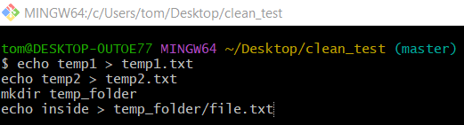
echo temp1 > temp1.txt
echo temp2 > temp2.txt
mkdir temp_folder
echo inside > temp_folder/file.txt
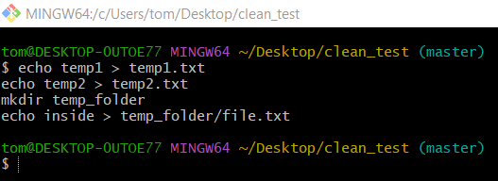
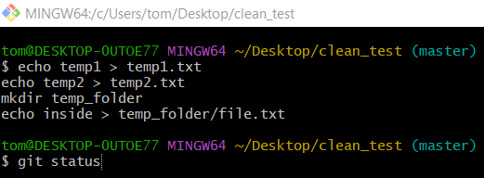
git status
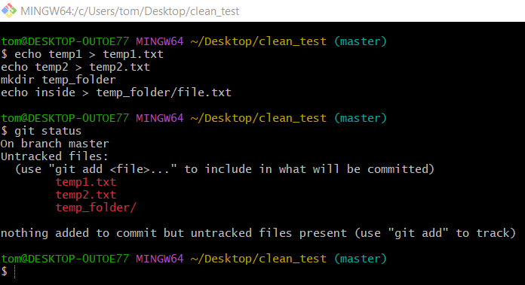

4️⃣ Preview what will be deleted
# Source: ScreenShots Source: Provided by: [Persons Table -> ID Column: 1, Name_En Column: Motasem Essam] -> Tool: [Lightshot Program] -> From [Operating System: Windows] on [2/19/2026]
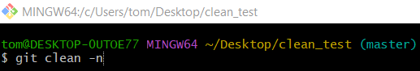
git clean -n
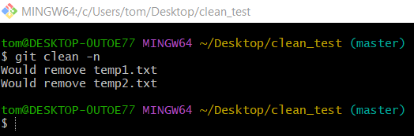
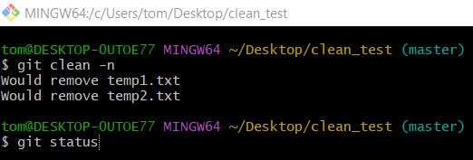
git status
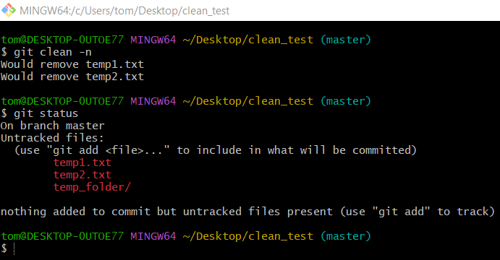

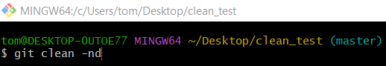
git clean -nd
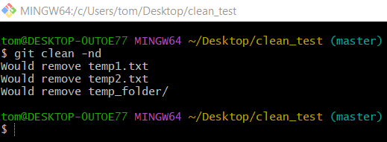
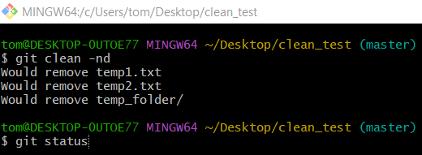
git status
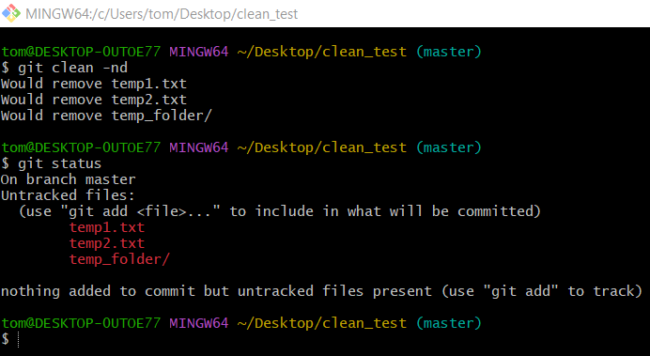

Remove untracked files only

1️⃣ Create a new test project
# Source: ScreenShots Source: Provided by: [Persons Table -> ID Column: 1, Name_En Column: Motasem Essam] -> Tool: [Lightshot Program] -> From [Operating System: Windows] on [2/19/2026]

mkdir clean_test
cd clean_test
git init


2️⃣ Create a tracked file
# Source: ScreenShots Source: Provided by: [Persons Table -> ID Column: 1, Name_En Column: Motasem Essam] -> Tool: [Lightshot Program] -> From [Operating System: Windows] on [2/19/2026]

echo tracked > tracked.txt
git add tracked.txt
git commit -m "Add tracked file"


3️⃣ Create untracked files and folders
# Source: ScreenShots Source: Provided by: [Persons Table -> ID Column: 1, Name_En Column: Motasem Essam] -> Tool: [Lightshot Program] -> From [Operating System: Windows] on [2/19/2026]

echo temp1 > temp1.txt
echo temp2 > temp2.txt
mkdir temp_folder
echo inside > temp_folder/file.txt


git status


4️⃣ Remove untracked files only
# Source: ScreenShots Source: Provided by: [Persons Table -> ID Column: 1, Name_En Column: Motasem Essam] -> Tool: [Lightshot Program] -> From [Operating System: Windows] on [2/19/2026]
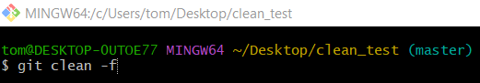
git clean -f
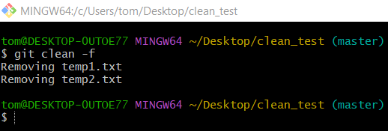
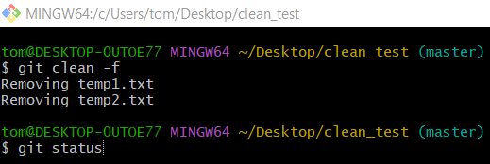
git status
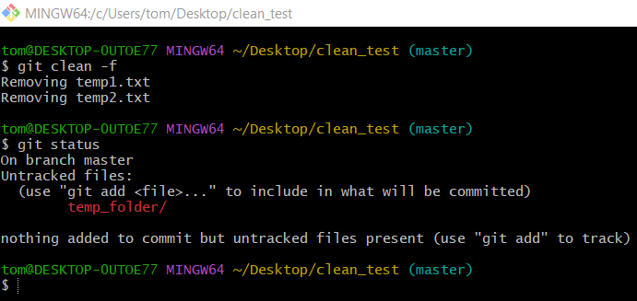

Remove untracked directories and files

1️⃣ Create a new test project
# Source: ScreenShots Source: Provided by: [Persons Table -> ID Column: 1, Name_En Column: Motasem Essam] -> Tool: [Lightshot Program] -> From [Operating System: Windows] on [2/19/2026]

mkdir clean_test
cd clean_test
git init


2️⃣ Create a tracked file
# Source: ScreenShots Source: Provided by: [Persons Table -> ID Column: 1, Name_En Column: Motasem Essam] -> Tool: [Lightshot Program] -> From [Operating System: Windows] on [2/19/2026]

echo tracked > tracked.txt
git add tracked.txt
git commit -m "Add tracked file"


3️⃣ Create untracked files and folders
# Source: ScreenShots Source: Provided by: [Persons Table -> ID Column: 1, Name_En Column: Motasem Essam] -> Tool: [Lightshot Program] -> From [Operating System: Windows] on [2/19/2026]

echo temp1 > temp1.txt
echo temp2 > temp2.txt
mkdir temp_folder
echo inside > temp_folder/file.txt


git status


4️⃣ Remove untracked directories and files
# Source: ScreenShots Source: Provided by: [Persons Table -> ID Column: 1, Name_En Column: Motasem Essam] -> Tool: [Lightshot Program] -> From [Operating System: Windows] on [2/19/2026]
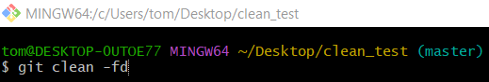
git clean -fd
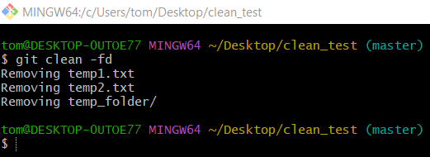
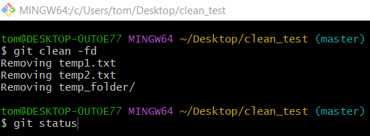
git status
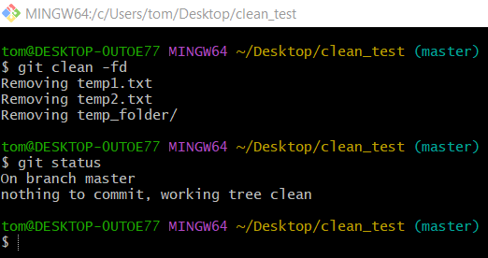

Interactive Mode

1️⃣ Create a new test project
# Source: ScreenShots Source: Provided by: [Persons Table -> ID Column: 1, Name_En Column: Motasem Essam] -> Tool: [Lightshot Program] -> From [Operating System: Windows] on [2/19/2026]

mkdir clean_test
cd clean_test
git init


2️⃣ Create a tracked file
# Source: ScreenShots Source: Provided by: [Persons Table -> ID Column: 1, Name_En Column: Motasem Essam] -> Tool: [Lightshot Program] -> From [Operating System: Windows] on [2/19/2026]

echo tracked > tracked.txt
git add tracked.txt
git commit -m "Add tracked file"


3️⃣ Create untracked files and folders
# Source: ScreenShots Source: Provided by: [Persons Table -> ID Column: 1, Name_En Column: Motasem Essam] -> Tool: [Lightshot Program] -> From [Operating System: Windows] on [2/19/2026]

echo temp1 > temp1.txt
echo temp2 > temp2.txt
mkdir temp_folder
echo inside > temp_folder/file.txt


git status


4️⃣ Create new untracked files again
# Source: ScreenShots Source: Provided by: [Persons Table -> ID Column: 1, Name_En Column: Motasem Essam] -> Tool: [Lightshot Program] -> From [Operating System: Windows] on [2/19/2026]
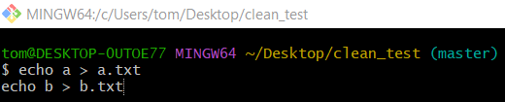
echo a > a.txt
echo b > b.txt
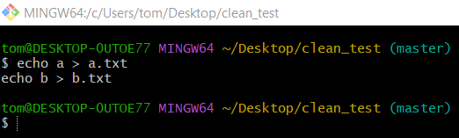
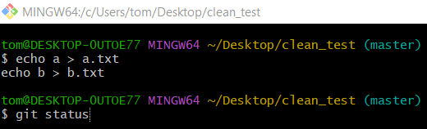
git status
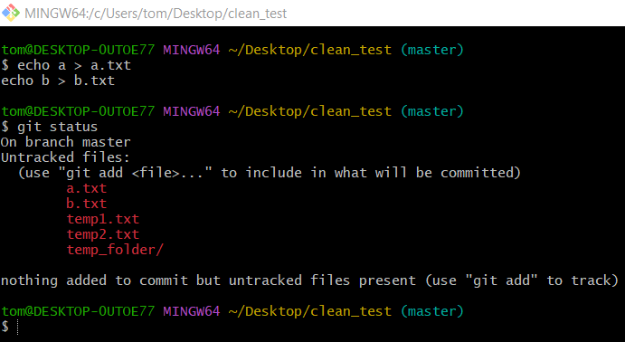

5️⃣ Interactive Mode
# Source: ScreenShots Source: Provided by: [Persons Table -> ID Column: 1, Name_En Column: Motasem Essam] -> Tool: [Lightshot Program] -> From [Operating System: Windows] on [2/19/2026]
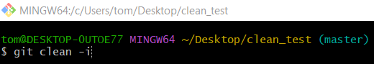
git clean -i
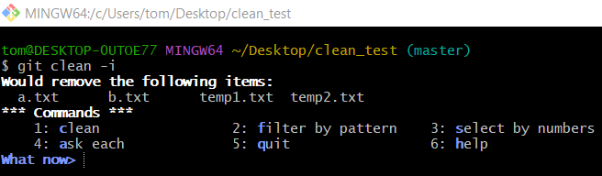
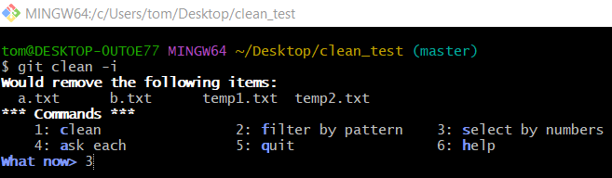
3
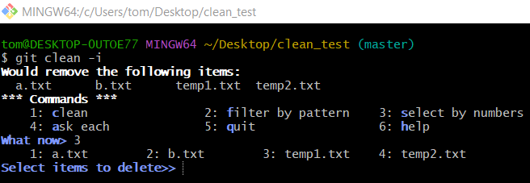
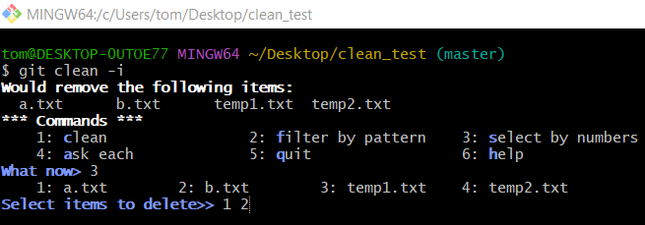
1 2
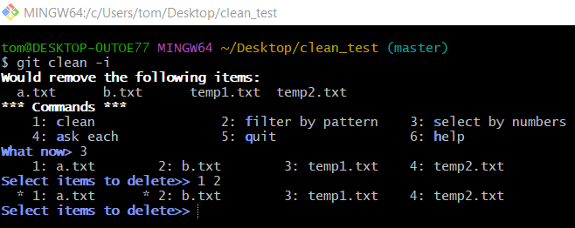
Enter
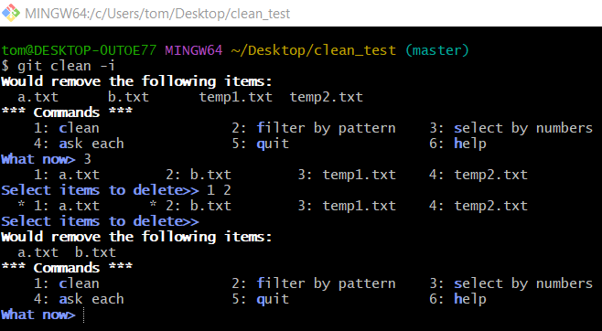
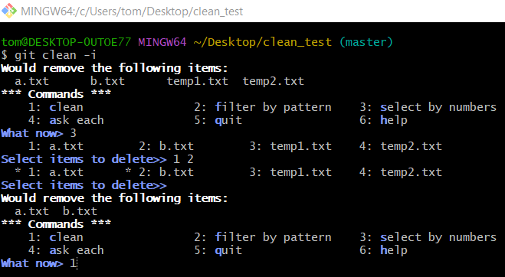
1
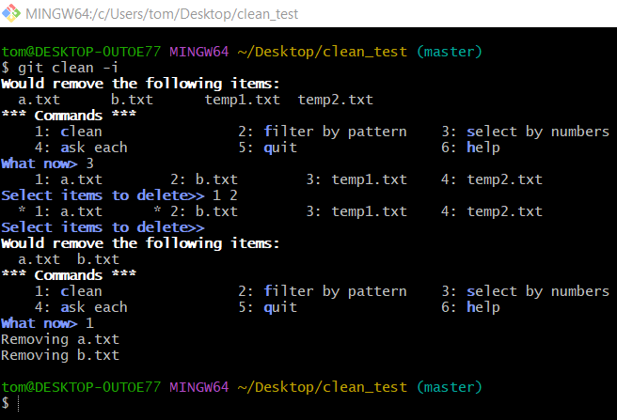

✅ Summary
# Source: AI Source: Provided by: [Data Path: Persons Table -> ID Column: 1, Name_En Column: Motasem Essam] -> From: [ChatGPT] on [2/19/2026]
Command | Source | Target/Effect
git clean | Working Directory | Deletes untracked files/directories
- git restore → resets tracked files to a previous state.
- git clean → deletes untracked files from workspace.

Git Restore

🔹 What is Git Restore?
# Source: AI Source: Provided by: [Data Path: Persons Table -> ID Column: 1, Name_En Column: Motasem Essam] -> From: [ChatGPT] on [2/19/2026]
git restore is a Git command used to discard changes in your working directory or staging area and bring files back to a previous state.
Think of it as a “revert to last saved version” tool for files.

🔹 What It Does
# Source: AI Source: Provided by: [Data Path: Persons Table -> ID Column: 1, Name_En Column: Motasem Essam] -> From: [ChatGPT] on [2/19/2026]
- Discard changes in the working directory (workspace):
git restore file.txt
- Replaces file.txt with the version from the last commit (HEAD).
- Any edits in your workspace are lost.

- Discard changes in the staging area (Index):
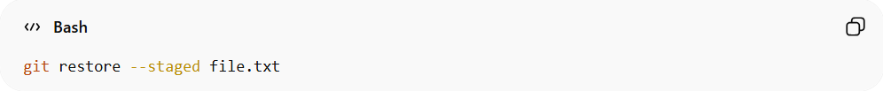
git restore --staged file.txt
- Removes file.txt from the staging area.
- Leaves the workspace version untouched.

- Restore from a specific commit:
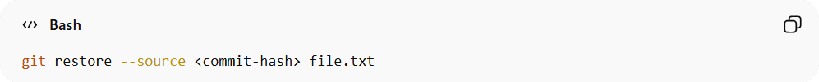
git restore --source <commit-hash> file.txt
- Replaces file.txt in your workspace with the version from <commit-hash>.

🔹 Where It Fits in Git Workflow
# Source: AI Source: Provided by: [Data Path: Persons Table -> ID Column: 1, Name_En Column: Motasem Essam] -> From: [ChatGPT] on [2/19/2026]
Git Workflow:
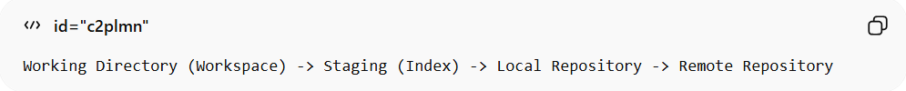
Working Directory (Workspace) -> Staging (Index) -> Local Repository -> Remote Repository
- git restore operates on the Workspace and optionally Staging.
- It does not affect commits in Local Repository unless you stage and commit afterward.

🔹 Resetting Your Working Directory to a Clean Slate
# Source: AI Source: Provided by: [Data Path: Persons Table -> ID Column: 1, Name_En Column: Motasem Essam] -> From: [ChatGPT] on [2/19/2026]
- You’re experimenting, made a mess, and want to reset your working directory:
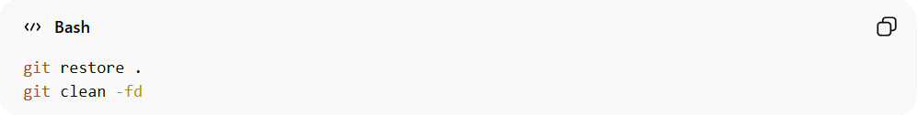
git restore .
git clean -fd
This resets tracked files and removes untracked files/directories, leaving a clean slate.

🔹 Key Notes
# Source: AI Source: Provided by: [Data Path: Persons Table -> ID Column: 1, Name_En Column: Motasem Essam] -> From: [ChatGPT] on [2/19/2026]
- Only affects tracked files.
- Does not delete untracked files; use git clean for that.
- Safer alternative to the old git checkout -- file.txt for discarding changes.

Example

Discard changes in the working directory (workspace)

1️⃣ Create a test project
# Source: ScreenShots Source: Provided by: [Persons Table -> ID Column: 1, Name_En Column: Motasem Essam] -> Tool: [Lightshot Program] -> From [Operating System: Windows] on [2/19/2026]
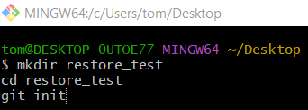
mkdir restore_test
cd restore_test
git init
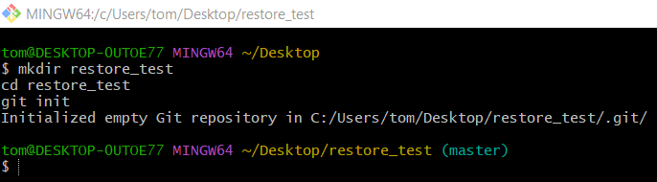

2️⃣ Create a file and commit it
# Source: ScreenShots Source: Provided by: [Persons Table -> ID Column: 1, Name_En Column: Motasem Essam] -> Tool: [Lightshot Program] -> From [Operating System: Windows] on [2/19/2026]
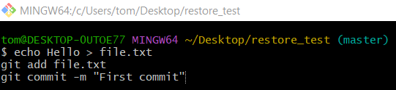
echo Hello > file.txt
git add file.txt
git commit -m "First commit"
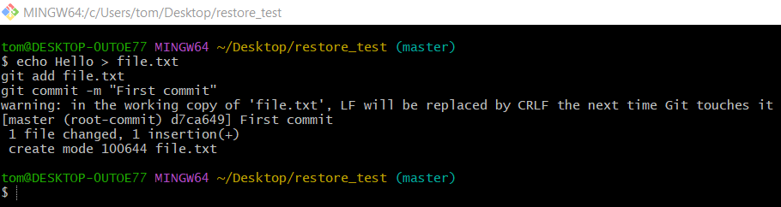

3️⃣ Modify the file
# Source: ScreenShots Source: Provided by: [Persons Table -> ID Column: 1, Name_En Column: Motasem Essam] -> Tool: [Lightshot Program] -> From [Operating System: Windows] on [2/19/2026]
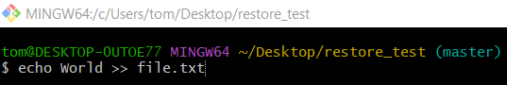
echo World >> file.txt
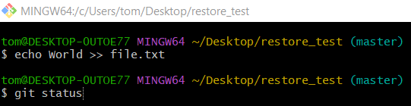
git status
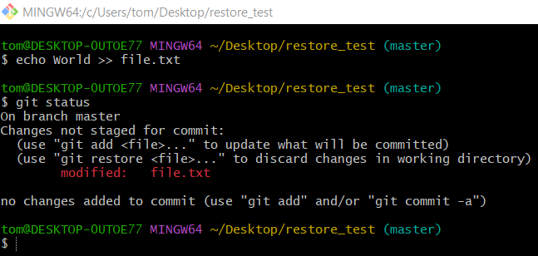

4️⃣ Test git restore (Workspace)
# Source: ScreenShots Source: Provided by: [Persons Table -> ID Column: 1, Name_En Column: Motasem Essam] -> Tool: [Lightshot Program] -> From [Operating System: Windows] on [2/19/2026]
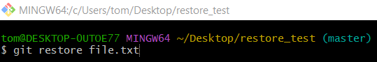
git restore file.txt
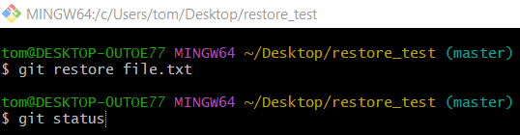
git status
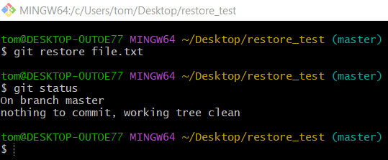

Discard changes in the staging area (Index)

1️⃣ Create a test project
# Source: ScreenShots Source: Provided by: [Persons Table -> ID Column: 1, Name_En Column: Motasem Essam] -> Tool: [Lightshot Program] -> From [Operating System: Windows] on [2/19/2026]

mkdir restore_test
cd restore_test
git init


2️⃣ Create a file and commit it
# Source: ScreenShots Source: Provided by: [Persons Table -> ID Column: 1, Name_En Column: Motasem Essam] -> Tool: [Lightshot Program] -> From [Operating System: Windows] on [2/19/2026]

echo Hello > file.txt
git add file.txt
git commit -m "First commit"


3️⃣ Modify the file
# Source: ScreenShots Source: Provided by: [Persons Table -> ID Column: 1, Name_En Column: Motasem Essam] -> Tool: [Lightshot Program] -> From [Operating System: Windows] on [2/19/2026]
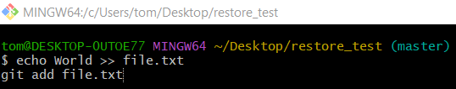
echo World >> file.txt
git add file.txt
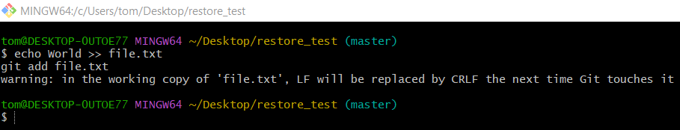
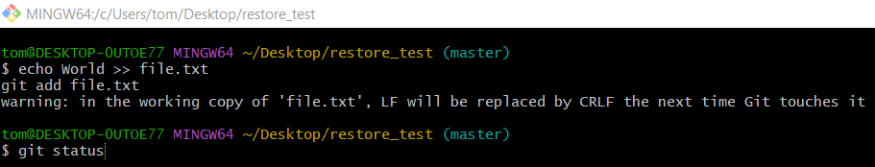
git status
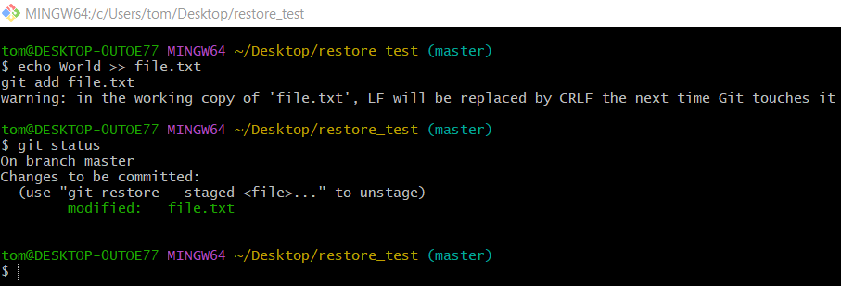

4️⃣ Remove from staging
# Source: ScreenShots Source: Provided by: [Persons Table -> ID Column: 1, Name_En Column: Motasem Essam] -> Tool: [Lightshot Program] -> From [Operating System: Windows] on [2/19/2026]
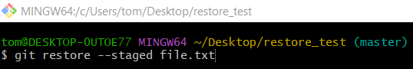
git restore --staged file.txt
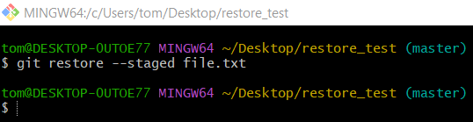
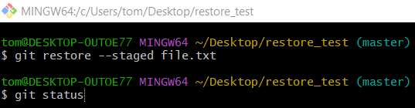
git status
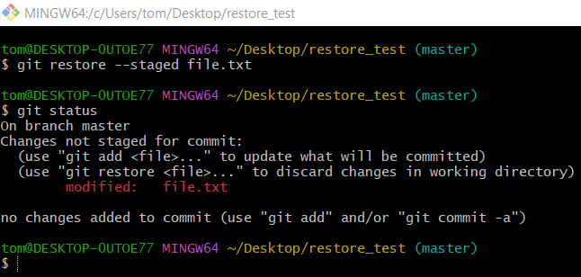

Restore from a specific commit

1️⃣ Create a test project
# Source: ScreenShots Source: Provided by: [Persons Table -> ID Column: 1, Name_En Column: Motasem Essam] -> Tool: [Lightshot Program] -> From [Operating System: Windows] on [2/19/2026]
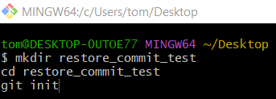
mkdir restore_commit_test
cd restore_commit_test
git init
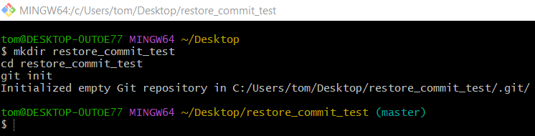

2️⃣ Create First Version (Commit 1)
# Source: ScreenShots Source: Provided by: [Persons Table -> ID Column: 1, Name_En Column: Motasem Essam] -> Tool: [Lightshot Program] -> From [Operating System: Windows] on [2/19/2026]
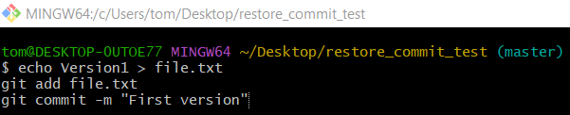
echo Version1 > file.txt
git add file.txt
git commit -m "First version"

3️⃣ Modify File (Commit 2)
# Source: ScreenShots Source: Provided by: [Persons Table -> ID Column: 1, Name_En Column: Motasem Essam] -> Tool: [Lightshot Program] -> From [Operating System: Windows] on [2/19/2026]
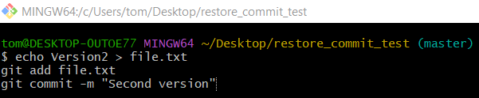
echo Version2 > file.txt
git add file.txt
git commit -m "Second version"
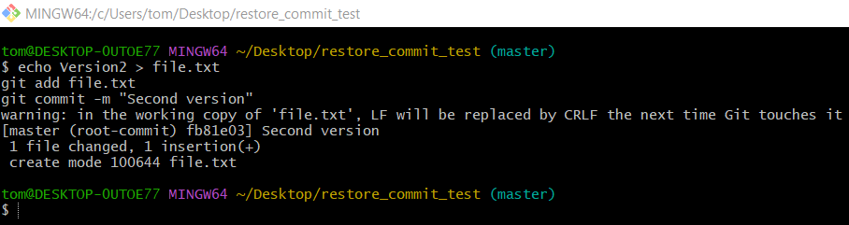

4️⃣ See Commit History
# Source: ScreenShots Source: Provided by: [Persons Table -> ID Column: 1, Name_En Column: Motasem Essam] -> Tool: [Lightshot Program] -> From [Operating System: Windows] on [2/19/2026]
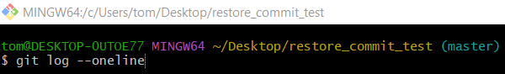
git log --oneline
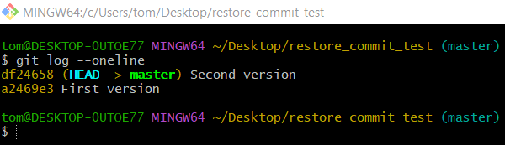

5️⃣ Restore file from First Commit
# Source: ScreenShots Source: Provided by: [Persons Table -> ID Column: 1, Name_En Column: Motasem Essam] -> Tool: [Lightshot Program] -> From [Operating System: Windows] on [2/19/2026]
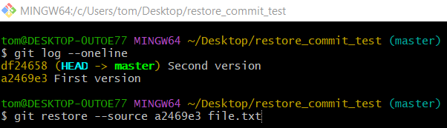
git restore --source a2469e3 file.txt

6️⃣ Check File Content
# Source: ScreenShots Source: Provided by: [Persons Table -> ID Column: 1, Name_En Column: Motasem Essam] -> Tool: [Lightshot Program] -> From [Operating System: Windows] on [2/19/2026]
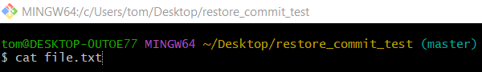
cat file.txt
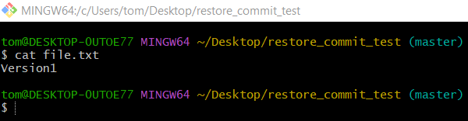

7️⃣ If You Want to Make It Official
# Source: ScreenShots Source: Provided by: [Persons Table -> ID Column: 1, Name_En Column: Motasem Essam] -> Tool: [Lightshot Program] -> From [Operating System: Windows] on [2/19/2026]
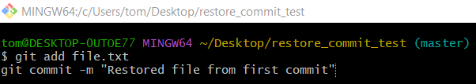
git add file.txt
git commit -m "Restored file from first commit"
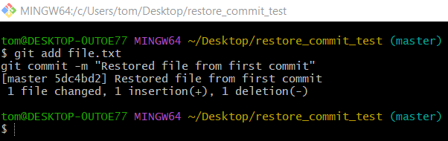

Resetting Your Working Directory to a Clean Slate

1. Create a test repository
# Source: ScreenShots Source: Provided by: [Persons Table -> ID Column: 1, Name_En Column: Motasem Essam] -> Tool: [Lightshot Program] -> From [Operating System: Windows] on [2/19/2026]
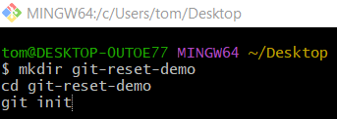
mkdir git-reset-demo
cd git-reset-demo
git init
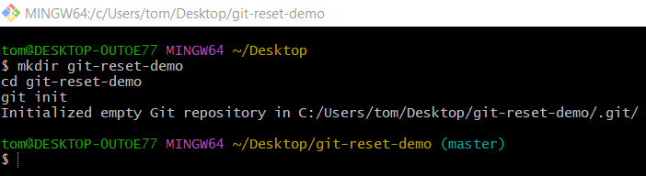

2. Create some files
# Source: ScreenShots Source: Provided by: [Persons Table -> ID Column: 1, Name_En Column: Motasem Essam] -> Tool: [Lightshot Program] -> From [Operating System: Windows] on [2/19/2026]
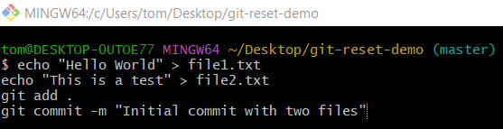
echo "Hello World" > file1.txt
echo "This is a test" > file2.txt
git add .
git commit -m "Initial commit with two files"
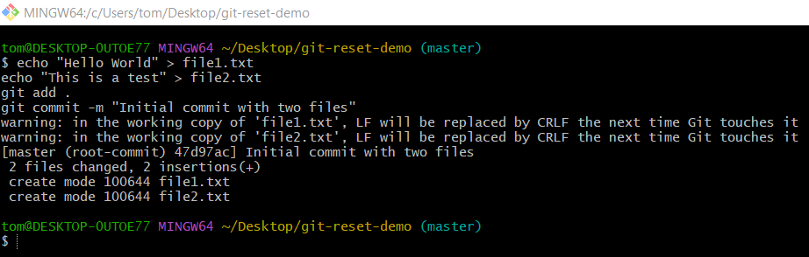

3. Make some changes
# Source: ScreenShots Source: Provided by: [Persons Table -> ID Column: 1, Name_En Column: Motasem Essam] -> Tool: [Lightshot Program] -> From [Operating System: Windows] on [2/19/2026]
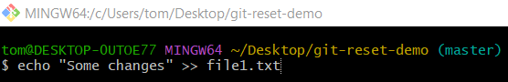
echo "Some changes" >> file1.txt
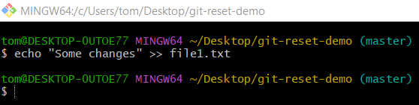
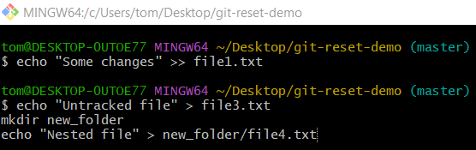
echo "Untracked file" > file3.txt
mkdir new_folder
echo "Nested file" > new_folder/file4.txt
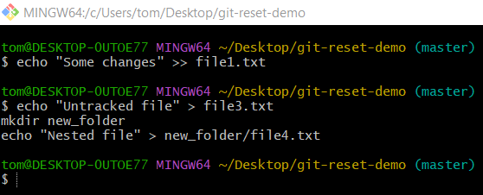
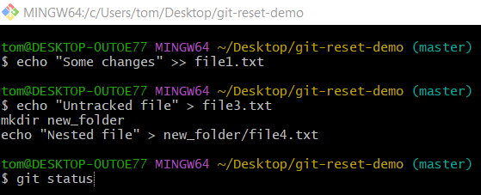
git status
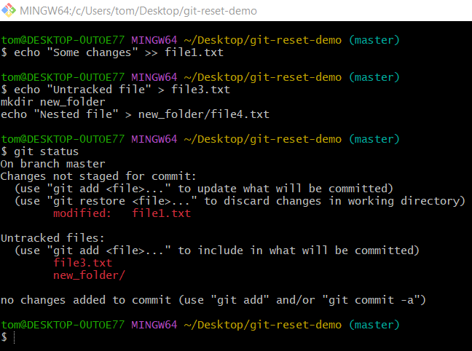

4. Reset everything
# Source: ScreenShots Source: Provided by: [Persons Table -> ID Column: 1, Name_En Column: Motasem Essam] -> Tool: [Lightshot Program] -> From [Operating System: Windows] on [2/19/2026]
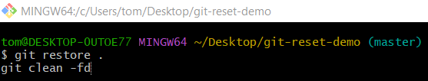
git restore .
git clean -fd
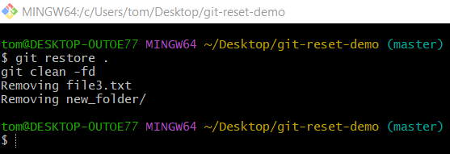

5. Verify the reset
# Source: ScreenShots Source: Provided by: [Persons Table -> ID Column: 1, Name_En Column: Motasem Essam] -> Tool: [Lightshot Program] -> From [Operating System: Windows] on [2/19/2026]
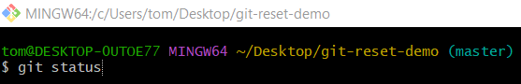
git status
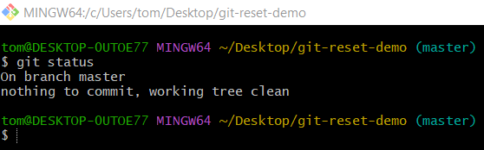

git restore vs git clean
# Source: AI Source: Provided by: [Data Path: Persons Table -> ID Column: 1, Name_En Column: Motasem Essam] -> From: [ChatGPT] on [2/19/2026]
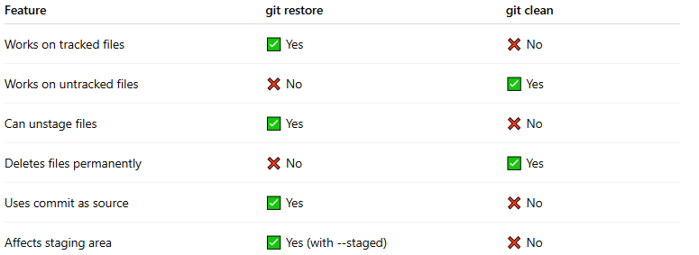
Feature | git restore | git clean
Works on tracked files | ✅ Yes | ❌ No
Works on untracked files | ❌ No | ✅ Yes
Can unstage files | ✅ Yes | ❌ No
Deletes files permanently | ❌ No | ✅ Yes
Uses commit as source | ✅ Yes | ❌ No
Affects staging area | ✅ Yes (with --staged) | ❌ No

✅ Summary
# Source: AI Source: Provided by: [Data Path: Persons Table -> ID Column: 1, Name_En Column: Motasem Essam] -> From: [ChatGPT] on [2/19/2026]
- git restore = restore file to last committed version
- From: Commit (HEAD) or Staging
- To: Workspace or Staging

Ignoring Files with .gitignore

What is .gitignore file
# Source: AI Source: Provided by: [Data Path: Persons Table -> ID Column: 1, Name_En Column: Motasem Essam] -> From: [ChatGPT] on [2/19/2026]
A .gitignore file is a special file used in Git to tell it which files or directories should not be tracked in your repository. Essentially, it prevents certain files from being added to commits.
Think of it as a “do not track” list for Git.

Why Use .gitignore?
# Source: AI Source: Provided by: [Data Path: Persons Table -> ID Column: 1, Name_En Column: Motasem Essam] -> From: [ChatGPT] on [2/19/2026]
- Avoid committing unnecessary files
  - Temporary files, build outputs, logs, caches, IDE configs, secrets.
  - Example: *.log, node_modules/, *.tmp.
- Keep your repository clean
  - Large or sensitive files that don’t belong in the repo.
- Improve performance
  - Git doesn’t need to track huge files like compiled binaries or video assets unless you explicitly want them.

How It Works
# Source: AI Source: Provided by: [Data Path: Persons Table -> ID Column: 1, Name_En Column: Motasem Essam] -> From: [ChatGPT] on [2/19/2026]
- You create a file called .gitignore in your repository root (or in subdirectories for folder-specific rules).
- Each line specifies a pattern for files or directories to ignore.

Basic Syntax
# Source: AI Source: Provided by: [Data Path: Persons Table -> ID Column: 1, Name_En Column: Motasem Essam] -> From: [ChatGPT] on [2/15/2026]
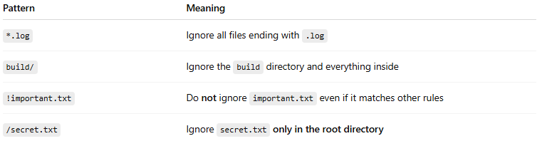
Pattern | Meaning
*.log | Ignore all files ending with .log
build/ | Ignore the build directory and everything inside
!important.txt | Do not ignore important.txt even if it matches other rules
/secret.txt | Ignore secret.txt only in the root directory

Example .gitignore for a Python project:
# Source: AI Source: Provided by: [Data Path: Persons Table -> ID Column: 1, Name_En Column: Motasem Essam] -> From: [ChatGPT] on [2/19/2026]
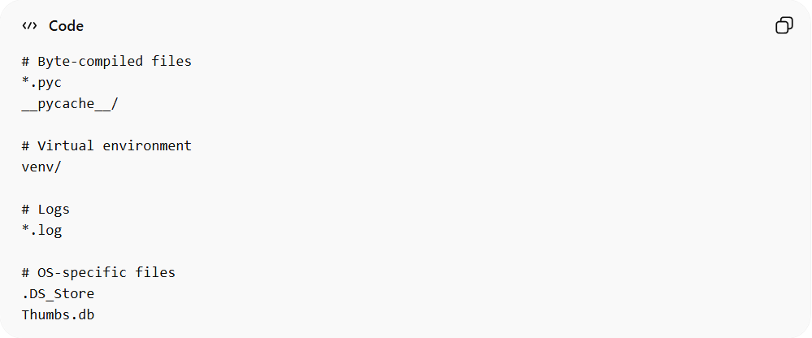
# Byte-compiled files
*.pyc
__pycache__/

# Virtual environment
venv/

# Logs
*.log

# OS-specific files
.DS_Store
Thumbs.db

Example for a Node.js project:
# Source: AI Source: Provided by: [Data Path: Persons Table -> ID Column: 1, Name_En Column: Motasem Essam] -> From: [ChatGPT] on [2/19/2026]
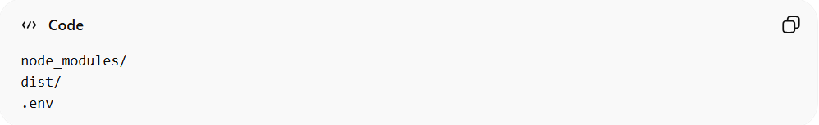
node_modules/
dist/
.env
Files listed in .gitignore won’t show up as untracked, and Git will not commit them.

Important Notes
# Source: AI Source: Provided by: [Data Path: Persons Table -> ID Column: 1, Name_En Column: Motasem Essam] -> From: [ChatGPT] on [2/19/2026]
- .gitignore only affects untracked files. If a file is already being tracked by Git, adding it to .gitignore does not stop Git from tracking it.
  - To stop tracking an already tracked file:
  - git rm --cached filename
- You can have multiple .gitignore files in different folders, and they are cumulative.

Full step-by-step example

Step 1: Create a test Git repository
# Source: AI Source: Provided by: [Data Path: Persons Table -> ID Column: 1, Name_En Column: Motasem Essam] -> From: [ChatGPT] on [2/19/2026]
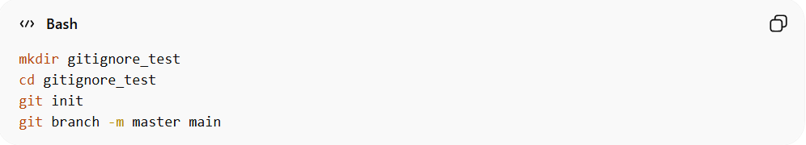
mkdir gitignore_test
cd gitignore_test
git init
git branch -m master main
- mkdir gitignore_test → creates a new folder for testing
- cd gitignore_test → moves into the folder
- git init → initializes a new Git repository
Check status:
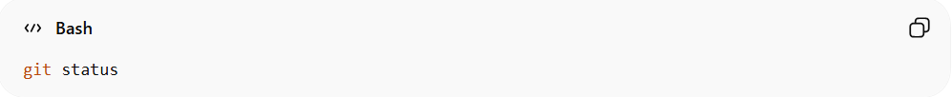
git status
You should see On branch main and nothing tracked yet.

Step 2: Create some test files
# Source: AI Source: Provided by: [Data Path: Persons Table -> ID Column: 1, Name_En Column: Motasem Essam] -> From: [ChatGPT] on [2/19/2026]
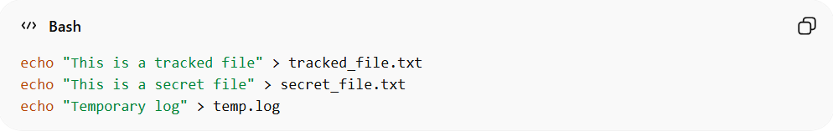
echo "This is a tracked file" > tracked_file.txt
echo "This is a secret file" > secret_file.txt
echo "Temporary log" > temp.log
- tracked_file.txt → normal file we’ll track
- secret_file.txt → file we want Git to ignore later
- temp.log → temporary file we want to ignore

Step 3: Check status
# Source: AI Source: Provided by: [Data Path: Persons Table -> ID Column: 1, Name_En Column: Motasem Essam] -> From: [ChatGPT] on [2/19/2026]
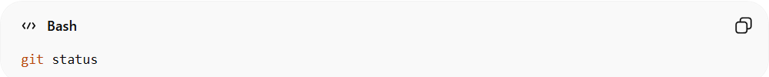
git status
Output will show all three files as untracked:
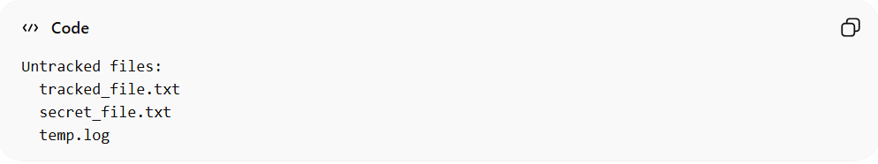
Untracked files:
tracked_file.txt
secret_file.txt
temp.log

Step 4: Create a .gitignore file
# Source: AI Source: Provided by: [Data Path: Persons Table -> ID Column: 1, Name_En Column: Motasem Essam] -> From: [ChatGPT] on [2/19/2026]
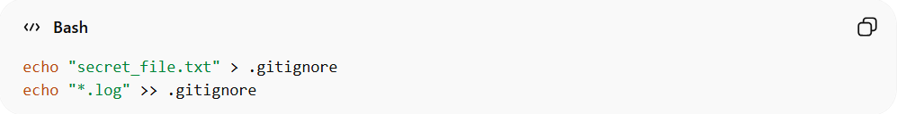
echo "secret_file.txt" > .gitignore
echo "*.log" >> .gitignore
- First line → ignore secret_file.txt
- Second line → ignore any .log files
Check .gitignore:
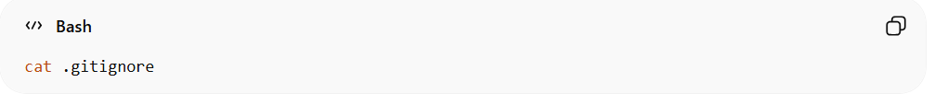
cat .gitignore
Output:
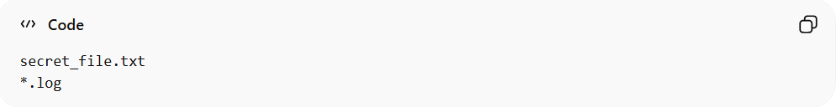
secret_file.txt
*.log

Step 5: Add files to Git
# Source: AI Source: Provided by: [Data Path: Persons Table -> ID Column: 1, Name_En Column: Motasem Essam] -> From: [ChatGPT] on [2/19/2026]
Check status:
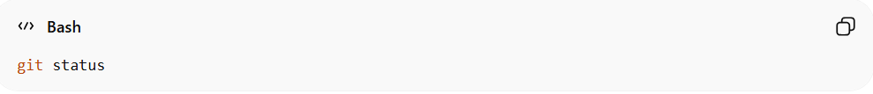
git status
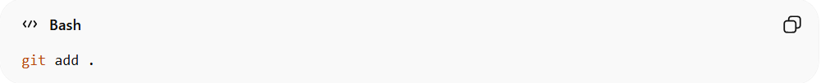
git add .
- Git will ignore files in .gitignore
- Only tracked_file.txt and .gitignore itself will be staged
Check status:

git status
Output should show:
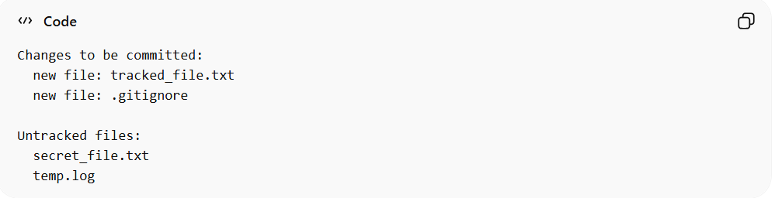
Changes to be committed:
new file: tracked_file.txt
new file: .gitignore

Untracked files:
secret_file.txt
temp.log
✅ .gitignore is working — untracked files listed in it are ignored automatically when adding with git add .

Step 6: Commit files
# Source: AI Source: Provided by: [Data Path: Persons Table -> ID Column: 1, Name_En Column: Motasem Essam] -> From: [ChatGPT] on [2/19/2026]
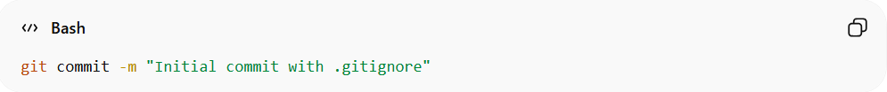
git commit -m "Initial commit with .gitignore"
- Only tracked_file.txt and .gitignore are committed
- secret_file.txt and temp.log remain untracked

Step 7: Test adding ignored file manually
# Source: AI Source: Provided by: [Data Path: Persons Table -> ID Column: 1, Name_En Column: Motasem Essam] -> From: [ChatGPT] on [2/19/2026]
If you try:
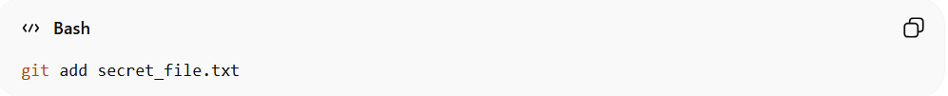
git add secret_file.txt
Git won’t add it because .gitignore prevents it.
If you want to force adding an ignored file:
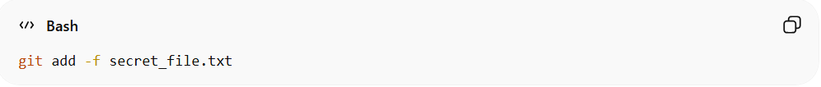
git add -f secret_file.txt

Step 8: Verify
# Source: AI Source: Provided by: [Data Path: Persons Table -> ID Column: 1, Name_En Column: Motasem Essam] -> From: [ChatGPT] on [2/19/2026]
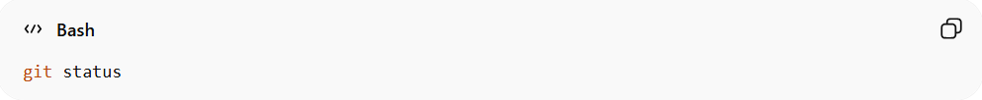
git status
You should see:
- Committed files: tracked_file.txt and .gitignore
- Ignored files: secret_file.txt and temp.log are not staged

Example

Step 1: Create a test Git repository
# Source: ScreenShots Source: Provided by: [Persons Table -> ID Column: 1, Name_En Column: Motasem Essam] -> Tool: [Lightshot Program] -> From [Operating System: Windows] on [2/19/2026]
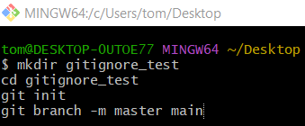
mkdir gitignore_test
cd gitignore_test
git init
git branch -m master main
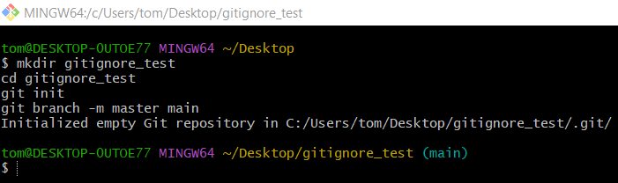

Step 2: Create some test files
# Source: ScreenShots Source: Provided by: [Persons Table -> ID Column: 1, Name_En Column: Motasem Essam] -> Tool: [Lightshot Program] -> From [Operating System: Windows] on [2/19/2026]
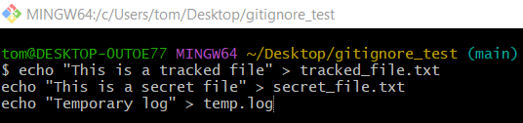
echo "This is a tracked file" > tracked_file.txt
echo "This is a secret file" > secret_file.txt
echo "Temporary log" > temp.log
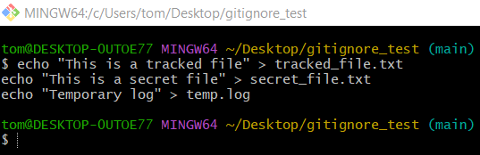

Step 3: Check status
# Source: ScreenShots Source: Provided by: [Persons Table -> ID Column: 1, Name_En Column: Motasem Essam] -> Tool: [Lightshot Program] -> From [Operating System: Windows] on [2/19/2026]
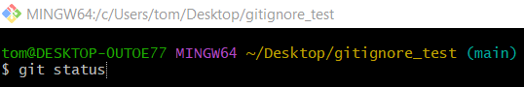
git status
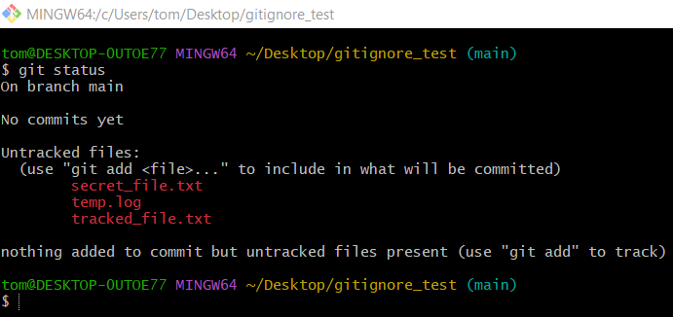

Step 4: Create a .gitignore file
# Source: ScreenShots Source: Provided by: [Persons Table -> ID Column: 1, Name_En Column: Motasem Essam] -> Tool: [Lightshot Program] -> From [Operating System: Windows] on [2/19/2026]
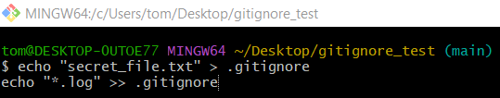
echo "secret_file.txt" > .gitignore
echo "*.log" >> .gitignore
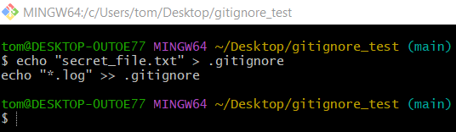
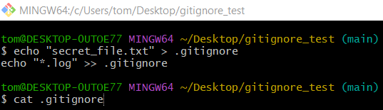
cat .gitignore
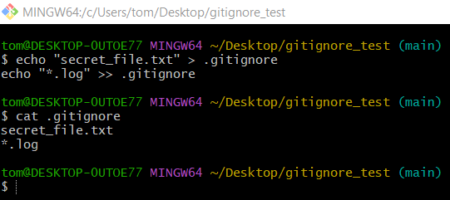

Step 5: Add files to Git
# Source: ScreenShots Source: Provided by: [Persons Table -> ID Column: 1, Name_En Column: Motasem Essam] -> Tool: [Lightshot Program] -> From [Operating System: Windows] on [2/19/2026]
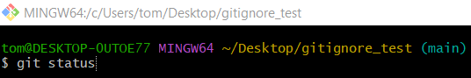
git status
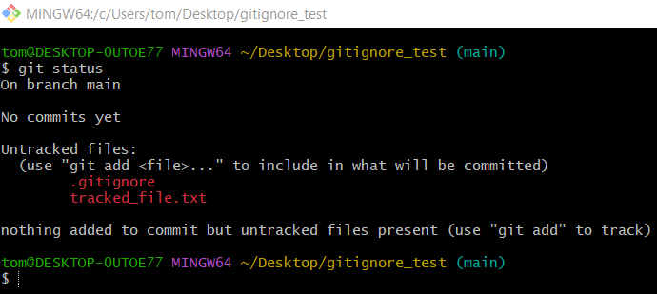
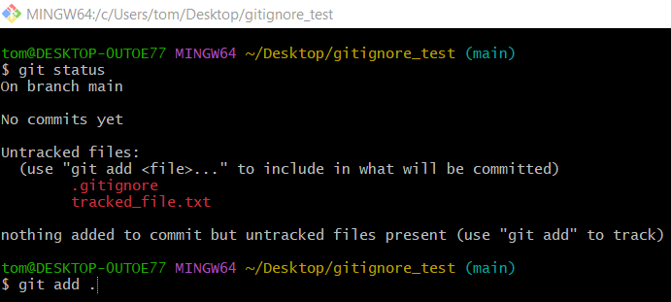
git add .
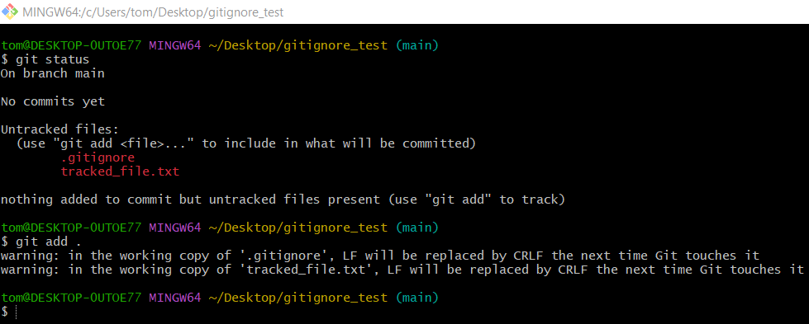
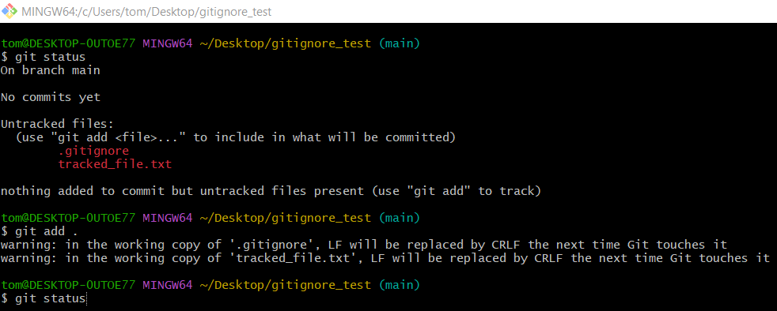
git status
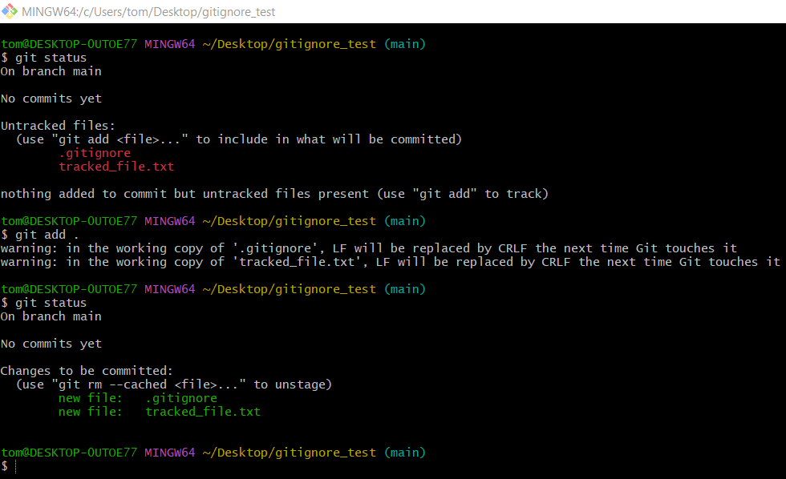

Step 6: Commit files
# Source: ScreenShots Source: Provided by: [Persons Table -> ID Column: 1, Name_En Column: Motasem Essam] -> Tool: [Lightshot Program] -> From [Operating System: Windows] on [2/19/2026]
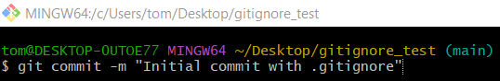
git commit -m "Initial commit with .gitignore"
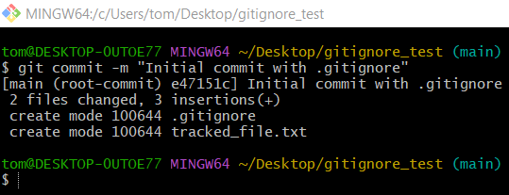

Step 7: Test adding ignored file manually
# Source: ScreenShots Source: Provided by: [Persons Table -> ID Column: 1, Name_En Column: Motasem Essam] -> Tool: [Lightshot Program] -> From [Operating System: Windows] on [2/19/2026]
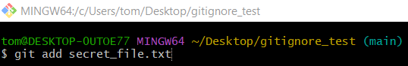
git add secret_file.txt
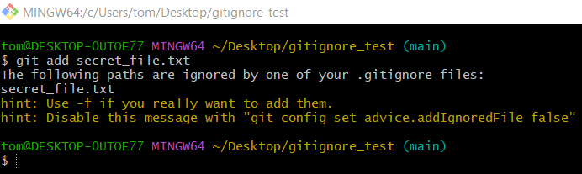
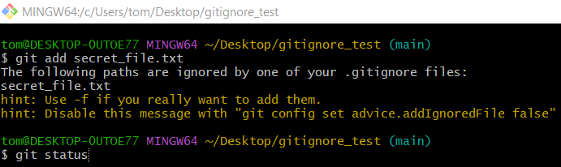
git status
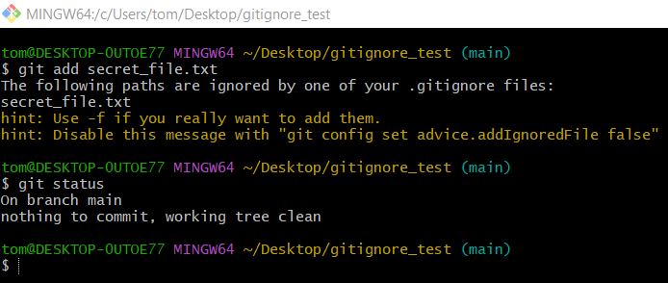
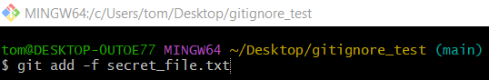
git add -f secret_file.txt
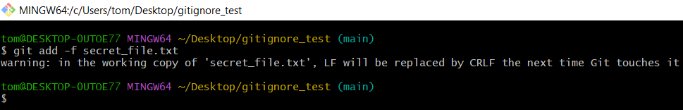

Step 8: Verify
# Source: ScreenShots Source: Provided by: [Persons Table -> ID Column: 1, Name_En Column: Motasem Essam] -> Tool: [Lightshot Program] -> From [Operating System: Windows] on [2/19/2026]

git status
